

IT342-G5

System Integration and Architecture

System Design Document (SDD)

Project Title: SynChef
Prepared By: Batawang, Vince Labadan

Version: 1.0
Date: 5/27/2026 Status: Deployment

REVISION HISTORY TABLE

Version | Date | Author | Changes Made | Status
0.1 | 2/20/2026 | Vince L. Batawang | Initial draft | Draft
0.2 | 2/25/2026 | Vince L. Batawang | Added API specifications | Completed
0.3 | 3/26/2026 | Vince L. Batawang | Updated database design | Completed
0.4 | 3/27/2026 | Vince L. Batawang | Added UI/UX designs | Completed
0.5 | 4/20/2026 | Vince L. Batawang | Incorporated feedback | Completed
0.6 | 5/04/2026 | Vince L. Batawang | Final review and corrections | Final
1 | 5/20/2026 | Vince L. Batawang | Baseline version for development | Approved

TABLE OF CONTENTS
Contents
EXECUTIVE SUMMARY 4
- INTRODUCTION 5
- FUNCTIONAL REQUIREMENTS SPECIFICATION 5
- NON-FUNCTIONAL REQUIREMENTS 8
- SYSTEM ARCHITECTURE 9
- API CONTRACT & COMMUNICATION 10
Authentication Endpoints 11
User Registration 11
User Login 11
- DATABASE DESIGN 13
- UI/UX DESIGN 14
- PLAN 17

EXECUTIVE SUMMARY

Project Overview

SynChef is a cross-platform smart culinary guidance system that transforms static recipes into an interactive, execution-focused cooking experience.
The project combines a Java Spring Boot backend (Maven), a Vite/React-based web frontend, an Android mobile client, and containerized deployments (Docker) to provide synchronized step orchestration, adaptive scaling, and culturally aware recipe recommendations.
SynChef prioritizes in-kitchen assistance with real-time timers, parallel task coordination, and minimal cognitive load for home cooks.

Objectives

    - Enable real-time orchestration of parallel cooking tasks and synchronized timers to simplify multi-step recipes.
    - Implement dynamic ingredient scaling and time adjustments to match household sizes and reduce food waste.
    - Provide culturally contextual recipe discovery and rule-based substitution suggestions to increase accessibility.
    - Deliver a step-focused “Focus Mode” UI to guide users through individual steps with clear, actionable prompts.
    - Expose RESTful APIs for recipes, steps, timers, scaling logic, and user data to support web and mobile clients.
    - Establish a modular, container-friendly architecture to enable future AI features (substitutions, timing optimization, personalization).

Scope Included Features:
- User accounts and authentication: registration, login, and profile management.
- Recipe browsing and discovery: filtering by cuisine, category, and dietary constraints.
- Parallel timer orchestration: coordinated timers and step synchronization across devices.
- Dynamic ingredient & time scaling: adjust quantities and durations based on servings and cookware.
- Step-by-step Focus Mode: simplified, sequential instructions with progress state.
- Rule-based cultural substitutions: MVP substitution suggestions for local ingredients.
- REST API services: endpoints for recipes, steps, timers, scaling, and user preferences.
- Relational data storage: production-ready database (Postgres or equivalent).
- Responsive web frontend (Vite/React) and Android client with Dockerized deployment artifacts.

Excluded Features:

- Full AI-driven personalization and recommendations (deferred to future phases).
- Voice assistant or hands-free voice control integration.
- Grocery delivery or external commerce integrations.
- Computer-vision-based cooking detection or real-time camera analysis.
- Social media sharing, community feeds, or in-app monetization/payments.
- Deep sensor integrations (IoT stove/smart cookware) in the initial release.

INTRODUCTION

Purpose
This document serves as the comprehensive design specification for the SynChef system. It provides detailed functional requirements, architectural decisions, API communication structure, database design considerations, and an implementation roadmap to guide the development process and ensure all system components integrate seamlessly.
By defining these specifications early, the document minimizes integration risks, prevents design inconsistencies, and establishes a structured foundation for delivering a reliable, scalable, and user-centered guided cooking platform.

FUNCTIONAL REQUIREMENTS SPECIFICATION

Project Overview
Project Name: SynChef
Domain: Smart Food Technology / Guided Cooking System

Primary Users:
- Home cooks
- Learners
- Food Enthusiasts
Problem Statement: Users lack an interactive system that can guide real-time cooking, coordinate simultaneous tasks, and adapt recipes dynamically to reduce waste and complexity.
Solution: SynChef converts recipes into synchronized, execution-driven workflows that guide users in real time with timers, scaled ingredients, and culturally contextual discovery.

Core User Journey

Journey 1: Guided Cooking Experience
    - User logs into the system.
    - Selects a recipe from the Flavor Map.
    - Inputs number of servings (Pax).
    - System recalculates ingredients and timing.
    - User enters Focus Mode.
    - Parallel timers guide task execution.
    - User completes cooking with synchronized alerts.

Journey 2: Exploring Global Cuisine
- User opens Flavor Map
- Selects continent → country
- Views culturally authentic recipes
- Reads ingredient background and preparation method
- Saves recipe to personal collection

Journey 3: Adjusting Meal Portions
- User selects a recipe
- Changes serving size
- System dynamically updates:
  - Ingredient quantities
  - Cooking durations
  - Required steps
- User proceeds with updated workflow

Feature List (MoSCoW) MUST HAVE
- User authentication (register/login/logout)
- Recipe management and retrieval
- Parallel timer execution engine
- Dynamic ingredient scaling
- Step-by-step Focus Mode
- Country-based recipe categorization
- RESTful API communication

SHOULD HAVE
- Ingredient substitution suggestions
- Recipe filtering by dietary category

- Saved recipes functionality
- Responsive UI animations for transitions

COULD HAVE
- AI-based timing optimization
- Personalized recommendations
- Multilingual instructions

WON'T HAVE
- Full AI automation
- Grocery ordering integration
- Smart kitchen device integration
- Voice-controlled cooking

Detailed Feature Specifications Feature: User Authentication
- Screens: Registration, Login
- Fields: Name, Email, Password, Confirm Password
- Validation: Email format validation, password length (min. 8 characters), uniqueness of account
- Security: JWT-based authentication, password hashing using Django authentication system

API Endpoints:
POST /api/auth/register POST /api/auth/login POST /api/auth/logout

Feature: Recipe Catalog Management
- Screens: Recipe Listing, Recipe Detail
- Display: Recipe image, name, country of origin, preparation time, servings
- Search: By recipe name, category, or country
- Filtering: Vegan, Dessert, Main Dish, etc.

API Endpoints:

GET /api/recipes GET /api/recipes/{id}
GET /api/recipes/search
GET /api/recipes/country/{country}

Feature: Global Flavor Map Navigation
- Screens: Interactive Map View, Country Selection View
- Display: Continent → Country navigation with cuisine highlights
- Functions: Load culturally relevant recipes based on selected region
- Purpose: Promote culinary education and cultural exploration

API Endpoints:
GET /api/countries
GET /api/recipes/country/{country}

Feature: Adaptive Parallel Timer System
- Screens: Cooking Mode, Active Timer Dashboard
- Functions: Run multiple cooking timers simultaneously, synchronize task completion
- Display: Countdown timers per step, alerts for next action
- Logic: Backend schedules step overlap to optimize cooking workflow

API Endpoints:
GET /api/recipes/timer-sequence/{id} POST /api/timers/start
POST /api/timers/update

Feature: Dynamic Ingredient Scaling
- Screens: Recipe Detail, Serving Adjustment Panel
- Fields: Number of servings (Pax input)
- Functions: Automatically recompute ingredient quantities and cooking duration
- Precision Handling: Decimal-based calculations for accurate scaling

API Endpoints:
POST /api/recipes/scale GET /api/recipes/{id}

Feature: Progressive Step-by-Step Focus Mode
- Screens: Focus Cooking Interface

- Display: One instruction visible at a time with navigation controls
- Functions: Prevent user distraction, guide sequential execution
- Integration: Syncs with timer engine for automated progression

API Endpoints:
GET /api/recipes/{id}/steps

Feature: Ingredient Substitution Assistance (Rule-Based MVP)
- Screens: Ingredient Information Panel
- Functions: Suggest alternative ingredients based on availability or region
- Logic: Predefined substitution mappings stored in database
- Purpose: Improve accessibility and reduce food waste

API Endpoints:
GET /api/ingredients/substitutions/{ingredient}

Feature: Saved Recipes / Personal Collection
- Screens: User Dashboard, Saved Recipes List
- Functions: Bookmark recipes for future cooking
- Persistence: Stored per authenticated user

API Endpoints:
GET /api/users/saved
POST /api/users/saved/{recipeId} DELETE /api/users/saved/{recipeId}

Acceptance Criteria

AC-1: Successful Recipe Execution
- Given a user selects a recipe
- When Focus Mode is activated
- Then the system must guide the user step-by-step
- And synchronize timers automatically
- And notify when each action must begin.

AC-2: Ingredient Scaling Accuracy
- Given a recipe designed for 4 servings

- When the user changes to 2 servings
- Then all ingredient values must adjust proportionally
- And updated measurements must display instantly.

AC-3: Parallel Task Coordination
- Given a recipe contains overlapping steps
- When cooking begins
- Then timers must run simultaneously
- And alerts must ensure synchronized completion.

AC-4: Cultural Recipe Discovery
- Given a user selects a country
- When recipes load
- Then the system must display cuisine-specific dishes
- And associated preparation context.

NON-FUNCTIONAL REQUIREMENTS

Performance Requirements

    - API response time: ≤ 2 seconds for 95% of requests
    - Web page load time: ≤ 3 seconds on broadband
    - Mobile app cold start: ≤ 3 seconds
    - Support 100 concurrent users
    - Database queries complete within 500ms

Security Requirements
    - HTTPS for all communications
    - JWT token authentication
    - Password hashing with bcrypt (salt rounds = 12)
    - SQL injection prevention
    - XSS protection
    - Rate limiting: 100 requests/minute per IP
    - Admin endpoints require role verification

Compatibility Requirements
    - Web Browsers: Chrome, Firefox, Safari, Edge (latest 2 versions)
    - Android: API Level 24+ (Android 7.0+)
    - Screen Sizes: Mobile (360px+), Tablet (768px+), Desktop (1024px+)
    - Operating Systems: Windows 10+, macOS 10.15+, Linux Ubuntu 20.04+

Usability Requirements
    - Complete first purchase within 5 minutes for new users
    - WCAG 2.1 Level AA compliance for web
    - Consistent navigation across all pages
    - Clear error messages with recovery options
    - Touch targets minimum 44x44px on mobile
    - Keyboard navigation support

SYSTEM ARCHITECTURE

Component Diagram

Note: This should be a component diagram

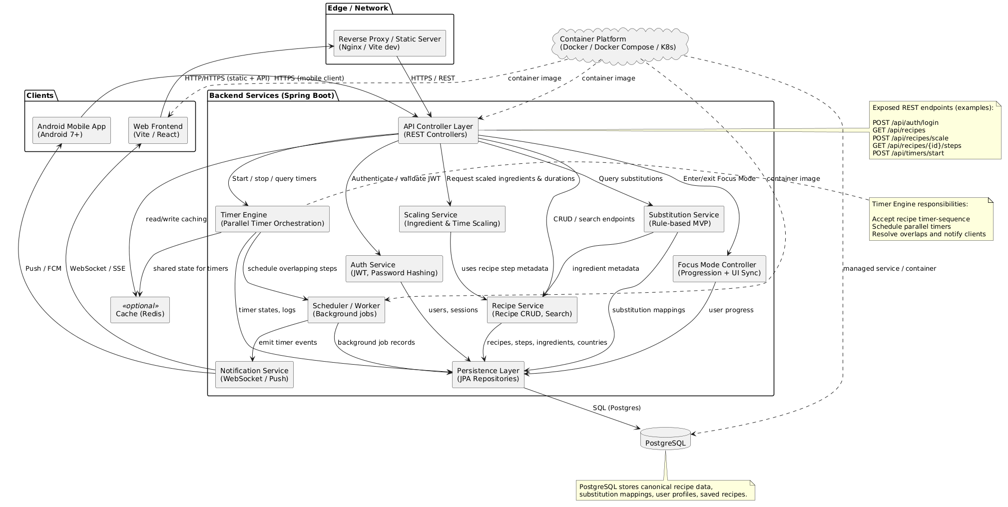

Technology Stack:
    - Backend: Java 17, Spring Boot 3.x, Spring Security, Spring Data JPA
    - Database: PostgreSQL 14+
    - Web Frontend: React 18, TypeScript, Tailwind CSS, Axios
    - Mobile: Kotlin, Jetpack Compose, Retrofit, Room
    - Build Tools: Maven (Backend), npm/yarn (Web), Gradle (Android)
    - Deployment: Railway/Heroku (Backend), Vercel/Netlify (Web), APK (Mobile)

API CONTRACT & COMMUNICATION

API Standards

Base URL | https://[server_hostname]:[port]/api/v1
Format | JSON for all requests/responses
Authentication | Bearer token (JWT) in Authorization header
Response Structure | {  "success": boolean, "data": object|null, "error": {  "code": string,  "message": string,

"details": object|null
},
"timestamp": string
}

Endpoint Specifications

Authentication Endpoints

User Registration

Description | User Registration
API URL | /auth/register
HTTP Request Method | POST
Format | JSON for all requests/responses
Authentication | None
Request Payload | {  “email”: <email>, “password”: <password>, “firstname”: <firstname>, “lastname”: <lastname>,  }
Response Structure | {  "success": boolean, "data": {  user {  “email”: <email>, “firstname”: <firstname>, “lastname”: <lastname>,  },  “accessToken”: <token>, “refreshToken”: <token>,  },  "error": { "code": string,  "message": string, "details": object|null  },  "timestamp": string  }

User Login

Description | User Login
API URL | /auth/login
HTTP Method | POST

Format | JSON for all requests/responses
Authentication | None
Request Payload | {  “email”: <email>, “password”: <password>,  }
Response Structure | {  "success": boolean, "data": {  “user”: {  “email”: <email>, “firstname”: <firstname>, “lastname”: <lastname>, “role”: <role>,  },  “accessToken”: <token>, “refreshToken”: <token>,  },  "error": { "code": string,  "message": string, "details": object|null  },  "timestamp": string  }

Error Handling HTTP Status Codes
    - 200 OK - Successful request
    - 201 Created - Resource created
    - 400 Bad Request - Invalid input
    - 401 Unauthorized - Authentication required/failed
    - 403 Forbidden - Insufficient permissions
    - 404 Not Found - Resource doesn't exist
    - 409 Conflict - Duplicate resource
    - 500 Internal Server Error - Server error

Error Code Examples

Example 1 | json  {  "success": false,

"data": null,
"error": {
"code": "AUTH-001",
"message": "Invalid credentials", "details": "Email or password is incorrect"
},
"timestamp": "2024-01-28T10:30:00Z"
}
Example 2 | {  "success": false, "data": null,  "error": {  "code": "VALID-001",  "message": "Validation failed", "details": {  "email": "Email is required",  "password": "Must be at least 8 characters"  }  },  "timestamp": "2024-01-28T10:30:00Z"  }

Common Error Codes
    - AUTH-001: Invalid credentials
    - AUTH-002: Token expired
    - AUTH-003: Insufficient permissions
    - VALID-001: Validation failed
    - DB-001: Resource not found
    - DB-002: Duplicate entry
    - BUSINESS-001: Insufficient stock
    - SYSTEM-001: Internal server error

DATABASE DESIGN

Entity Relationship Diagram

Note: This should be an ERD (Database Schema)

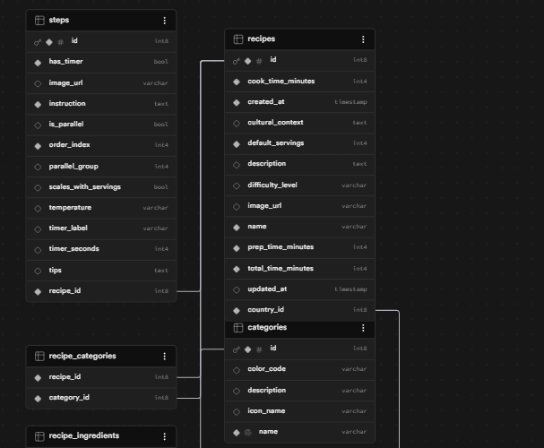

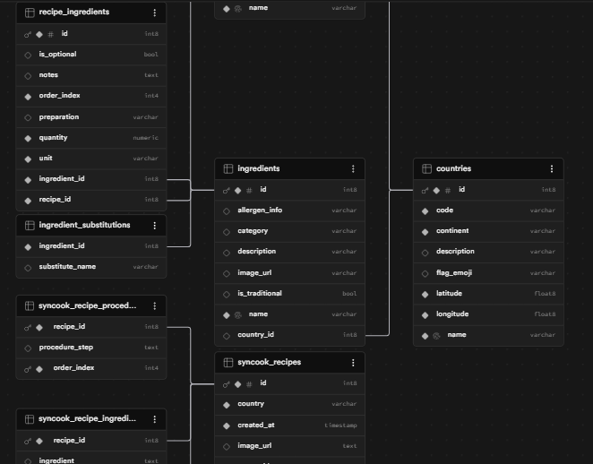

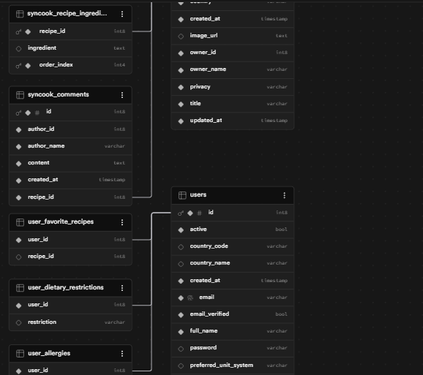

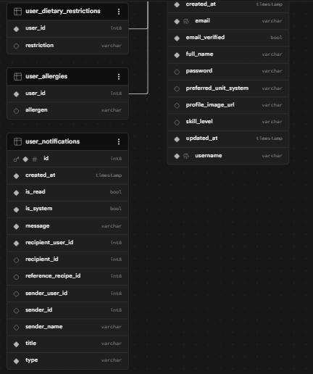

Detailed Relationships:

- One-to-One: User ↔ Cart (Each user has exactly one cart)
- One-to-Many: User → Orders (User can have multiple orders)
- One-to-Many: Cart → CartItems (Cart contains multiple items)
- One-to-Many: Order → OrderItems (Order contains multiple items)
- Many-to-One: CartItems → Product (Items reference products)
- Many-to-One: OrderItems → Product (Items reference products)

Key Tables:
- users - User accounts and authentication
- products - Product catalog information
- carts - Shopping cart per user
- cart_items - Items in shopping cart
- orders - Customer orders
- order_items - Items in each order
- refresh_tokens - JWT refresh tokens

Table Structure Summary:
  - users: id, email, password_hash, full_name, role, created_at
  - products: id, name, description, price, stock, image_url, category
  - carts: id, user_id, created_at
  - cart_items: id, cart_id, product_id, quantity
  - orders: id, order_number, user_id, total, status, shipping_address
  - order_items: id, order_id, product_id, product_name, quantity, price

UI/UX DESIGN

Web Application Wireframes

Note: This should be wireframes from Figma

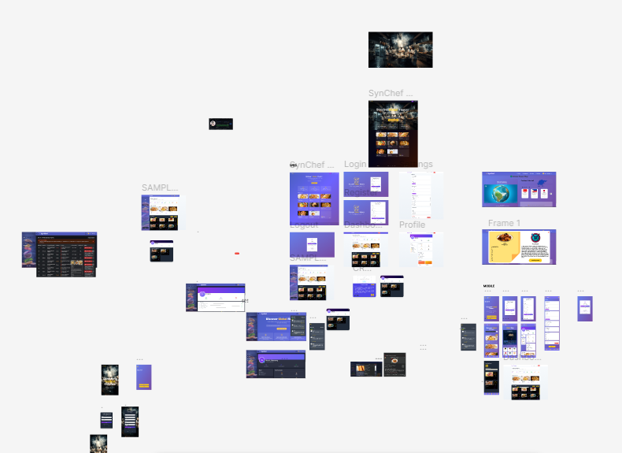

Homepage (Product Listing)
Header: [Logo] [Search Bar] [Cart Icon] [User Menu] Content: Product Grid (3 columns desktop)
Each Product Card: Image, Name, Price, "Add to Cart" button Footer: Links, Copyright

Product Detail Page
Back Button
Product Image (large) Product Name and Price Description
Quantity Selector (1-10)
"Add to Cart" and "Buy Now" buttons Product Specifications

Shopping Cart Page
Cart Title
List of Cart Items (Image, Name, Quantity, Price, Remove)
Order Summary: Subtotal, Shipping, Tax, Total
"Continue Shopping" and "Proceed to Checkout" buttons

Checkout Page
Shipping Address Form
Order Review (Items, Prices, Totals) "Place Order" button
Terms and Conditions note

Admin Dashboard
Sidebar Navigation: Dashboard, Products, Orders, Users
Product Management: Add New button, Product list with Edit/Delete Order Management: Order list with status filters

Mobile Application Wireframes

Note: This should be wireframes from Figma

Bottom Navigation
[🏠 Home] [🔍 Search] [🛒 Cart] [👤 Profile]

Home Screen
Search Bar
Product Grid (2 columns)
Swipe gestures for quick actions Pull to refresh

Product Detail Screen
Back arrow
Product image (swipeable gallery) Product info
Quantity selector
"Add to Cart" fixed bottom button

Cart Screen
Edit mode for quantity updates Swipe to remove items
Order summary sticky bottom Checkout button

Checkout Flow

Step indicator: Cart → Shipping → Payment → Confirm

Address form (auto-complete) Order summary

Place order button

Mobile-Specific Features:
- Touch-optimized buttons (min 44x44px)
- Gesture support (swipe, pull-to-refresh)
- Offline caching for product images
- Bottom navigation for main actions
- Simplified forms for mobile input

Design System:
- Colors: Primary (#2563EB), Secondary (#7C3AED), Success (#10B981), Error (#EF4444)
- Typography: Inter font family, responsive sizing
- Spacing: 8px grid system
- Components: Consistent buttons, inputs, cards, modals
- Responsive: Mobile-first approach, breakpoints at 640px, 768px, 1024px

PLAN

Project Timeline

Phase 1: Planning & Design (Week 1-2)
Week 1: Requirements & Architecture
Day 1-2: Project setup and documentation Day 3-4: Complete FRS and NFR
Day 5-7: System architecture design

Week 2: Detailed Design Day 1-2: API specification Day 3-4: Database design Day 5-6: UI/UX wireframes

Day 7: Implementation plan finalization

Phase 2: Backend Development (Week 3-4)
Week 3: Foundation
Day 1: Spring Boot setup with dependencies Day 2: Database configuration and entities Day 3: JWT authentication implementation Day 4: User management endpoints
Day 5: Product CRUD operations

Week 4: Core Features Day 1: Cart functionality Day 2: Order management Day 3: Search and filtering
Day 4: Error handling and validation Day 5: API documentation and testing

Phase 3: Web Application (Week 5-6)
Week 5: Frontend Foundation
Day 1: React setup with TypeScript
Day 2: Authentication pages (login, register) Day 3: Product listing page
Day 4: Product detail page
Day 5: Shopping cart implementation

Week 6: Complete Web Features Day 1: Checkout flow

Day 2: Order history and confirmation Day 3: Admin dashboard
Day 4: Responsive design polish Day 5: API integration and testing

Phase 4: Mobile Application (Week 7-8)
Week 7: Android Foundation
Day 1: Android Studio setup and project structure Day 2: Authentication screens
Day 3: Product browsing Day 4: Shopping cart Day 5: API service layer

Week 8: Complete Mobile App Day 1: Checkout flow
Day 2: Order management
Day 3: UI polish and animations Day 4: Testing on emulator/device
Day 5: APK generation and documentation

Phase 5: Integration & Deployment (Week 9-10)
Week 9: Integration Testing
Day 1: End-to-end testing across platforms Day 2: Bug fixes and optimization
Day 3: Security review
Day 4: Performance testing Day 5: Documentation updates

Week 10: Deployment
Day 1: Backend deployment (Railway/Heroku) Day 2: Web app deployment (Vercel/Netlify) Day 3: Mobile APK distribution
Day 4: Final testing
Day 5: Project submission

Milestones:
- M1 (End Week 2): All design documents complete
- M2 (End Week 4): Backend API fully functional
- M3 (End Week 6): Web application complete
- M4 (End Week 8): Mobile application complete
- M5 (End Week 10): Full system deployed and integrated

Critical Path:
- Authentication system (Week 3)
- Product catalog API (Week 3-4)
- Shopping cart functionality (Week 4)
- Checkout process (Week 6)
- Cross-platform testing (Week 9)

Risk Mitigation:
  - Start with simplest working version of each feature
  - Test integration points early and often
  - Keep backup of working versions
  - Focus on core functionality before enhancements

